Section A - Entity Relationship Diagram (ERD)

Entities (Minimum 6)
The RaceDay system requires the following entities:
# | Entity | Description
1 | Users | System users (Organisers and Participants) with role-based access
2 | Events | Racing events created by organisers
3 | Categories | Race categories within an event (e.g., 5K, 10K, Half Marathon)
4 | Enrolments | Participant registrations for specific event categories
5 | Results | Race results for each enrolment (finish time, position, etc.)
6 | Payments | Payment records for event enrolments
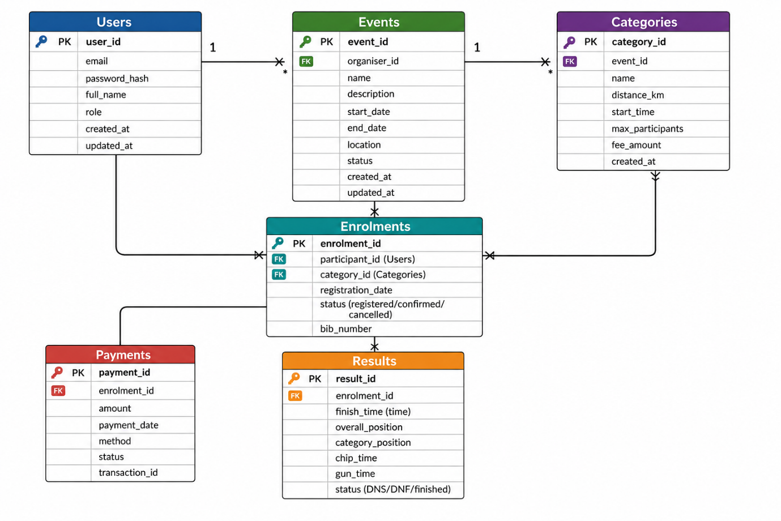

Relationship | Cardinality
Users → Events (organiser) | One-to-Many (one organiser can create many events)
Events → Categories | One-to-Many (one event can have many categories)
Users → Enrolments (participant) | One-to-Many (one participant can have many enrolments)
Categories → Enrolments | One-to-Many (one category can have many enrolments)
Enrolments → Results | One-to-One (each enrolment has one result)
Enrolments → Payments | One-to-Many (one enrolment can have multiple payments)

Authentication Endpoints
HTTP Method | Route | Description | Role Required | Request Body | Expected Response
POST | /api/auth/register | Register a new user account (organiser or participant) | None (public) | { email, password, fullName, role } | 201 Created - user details without password 400 Bad Request - validation error 409 Conflict - email already exists
POST | /api/auth/login | Authenticate user and return JWT token | None (public) | { email, password } | 200 OK - { token, user } 401 Unauthorised - invalid credentials

User Profile Endpoints
HTTP Method | Route | Description | Role Required | Request Body | Expected Response
GET | /api/users/me | Get current logged-in user's profile | Any (logged in) | None | 200 OK - user profile 401 Unauthorised - not logged in
PUT | /api/users/me | Update current user's profile | Any (logged in) | { fullName, email } | 200 OK - updated user 400 Bad Request - validation error
GET | /api/users/{id} | Get a specific user's public profile | Any (logged in) | None | 200 OK - public user profile 404 Not Found - user not found
GET | /api/users/me/enrolments | Get all enrolments for the current user | Any (logged in) | None | 200 OK - list of enrolments with event and category details

Event Endpoints
HTTP Method | Route | Description | Role Required | Request Body | Expected Response
GET | /api/events | Get all events (with optional filters) | None (public) | None (query params: status, dateFrom, dateTo, organiserId) | 200 OK - list of events
GET | /api/events/{id} | Get a specific event by ID | None (public) | None | 200 OK - event details with categories 404 Not Found - event not found
POST | /api/events | Create a new event | Organiser | { name, description, startDate, endDate, location, status } | 201 Created - new event 400 Bad Request - validation error
PUT | /api/events/{id} | Update an existing event | Organiser (event owner) | { name, description, startDate, endDate, location, status } | 200 OK - updated event 403 Forbidden - not event owner 404 Not Found - event not found
DELETE | /api/events/{id} | Delete an event (and all associated categories/enrolments) | Organiser (event owner) | None | 204 No Content 403 Forbidden - not event owner 404 Not Found - event not found
GET | /api/events/{id}/enrolments | Get all enrolments for a specific event | Any (logged in) | None | 200 OK - list of enrolments with participant details

Category Endpoints
HTTP Method | Route | Description | Role Required | Request Body | Expected Response
GET | /api/events/{eventId}/categories | Get all categories for an event | None (public) | None | 200 OK - list of categories 404 Not Found - event not found
POST | /api/events/{eventId}/categories | Add a new category to an event | Organiser (event owner) | { name, distanceKm, startTime, maxParticipants, feeAmount } | 201 Created - new category 403 Forbidden - not event owner 404 Not Found - event not found
PUT | /api/categories/{id} | Update an existing category | Organiser (event owner) | { name, distanceKm, startTime, maxParticipants, feeAmount } | 200 OK - updated category 403 Forbidden - not event owner 404 Not Found - category not found
DELETE | /api/categories/{id} | Delete a category | Organiser (event owner) | None | 204 No Content 403 Forbidden - not event owner 404 Not Found - category not found

Enrolment Endpoints
HTTP Method | Route | Description | Role Required | Request Body | Expected Response
POST | /api/enrolments | Register a participant for an event category | Participant | { categoryId } | 201 Created - enrolment details 400 Bad Request - already enrolled or category full 404 Not Found - category not found
GET | /api/enrolments/{id} | Get a specific enrolment by ID | Participant (own) or Organiser | None | 200 OK - enrolment with participant/event details 403 Forbidden - not authorised 404 Not Found - enrolment not found
PUT | /api/enrolments/{id} | Update enrolment status (cancel/confirm) | Participant (own) or Organiser | { status } | 200 OK - updated enrolment 403 Forbidden - not authorised 404 Not Found - enrolment not found
DELETE | /api/enrolments/{id} | Cancel/delete an enrolment | Participant (own) or Organiser | None | 204 No Content 403 Forbidden - not authorised 404 Not Found - enrolment not found
GET | /api/events/{eventId}/enrolments | Get all enrolments for an event (with results) | Organiser (event owner) | None | 200 OK - list of enrolments with participant and result data 403 Forbidden - not event owner

Result Endpoints
HTTP Method | Route | Description | Role Required | Request Body | Expected Response
POST | /api/enrolments/{enrolmentId}/results | Record a result for an enrolment | Organiser (event owner) | { finishTime, overallPosition, categoryPosition, chipTime, gunTime, status } | 201 Created - result details 403 Forbidden - not event owner 404 Not Found - enrolment not found
GET | /api/enrolments/{enrolmentId}/results | Get result for a specific enrolment | Participant (own) or Organiser | None | 200 OK - result details 404 Not Found - result not found
PUT | /api/results/{id} | Update an existing result | Organiser (event owner) | { finishTime, overallPosition, categoryPosition, chipTime, gunTime, status } | 200 OK - updated result 403 Forbidden - not event owner 404 Not Found - result not found
DELETE | /api/results/{id} | Delete a result | Organiser (event owner) | None | 204 No Content 403 Forbidden - not event owner 404 Not Found - result not found
GET | /api/events/{eventId}/results | Get all results for an event (leaderboard) | None (public) | None (query: categoryId, topN) | 200 OK - list of results with participant names and positions
GET | /api/categories/{categoryId}/results | Get results for a specific category | None (public) | None | 200 OK - category results leaderboard

Payment Endpoints
HTTP Method | Route | Description | Role Required | Request Body | Expected Response
POST | /api/enrolments/{enrolmentId}/payments | Process a payment for an enrolment | Participant | { amount, method } | 201 Created - payment details 400 Bad Request - invalid payment 404 Not Found - enrolment not found
GET | /api/enrolments/{enrolmentId}/payments | Get all payments for an enrolment | Participant (own) or Organiser | None | 200 OK - list of payments 403 Forbidden - not authorised
GET | /api/payments/{id} | Get a specific payment by ID | Participant (own) or Organiser | None | 200 OK - payment details 403 Forbidden - not authorised 404 Not Found - payment not found

